When AI recruitment shapes talent: Evidence-aware hiring, skill investment, and resource-linked opportunity inequality in a computational labor market
Qingyu Luo¹ · Shiqing Peng²
¹ School of Humanities and Social Sciences, Beihang University, Beijing, China
² School of Computer Science and Engineering, Beihang University, Beijing, China
Article type: Research article

Abstract
AI recruitment systems may do more than sort applicants: when they return evidence-aware assessments, explain skill gaps, and prescribe development tasks, they can change later skill investment and the distribution of opportunity. This article examines AI recruitment as a socio-technical feedback institution using a controlled agent-based labor-market experiment with four sequential regimes: credential/text screening, evidence-aware ranking, evidence-aware ranking with explanations, and evidence-aware ranking with active development tasks. Across 40 paired stochastic societies, the evidence-ranking/information-set intervention raises the conditional latent fit of hires but reduces short-run market clearing and aggregate realized fit per available position. Explanatory feedback redirects learning effort toward missing skills, while active tasks increase realized skill gains and weak-to-verifiable evidence conversion without improving six-round placement. In a 2 × 2 × 2 structural design, the direct paired evidence-channel effect on the R1-R0 resource-linked placement-gap change is +0.133 (95% CI 0.041 to 0.225; p=0.0096; 10 paired seeds), whereas evidence-by-learning and evidence-by-credential-resource interactions are not detectable. The simulated credential-sensitivity decline disappears or reverses when the evidence-confidence discount rule is removed, so it is treated as a construct check. These results identify model-generated risk mechanisms under specified assumptions rather than empirical effect sizes for real labor markets.
Keywords: AI recruitment; algorithmic feedback; skills-based hiring; agent-based modeling; opportunity inequality; technology governance

1 Introduction
Artificial intelligence is increasingly embedded in recruitment, employability platforms, and skills-based hiring initiatives. Yet the dominant evaluation lens still treats recruitment AI as a ranking or prediction device: given resumes and job descriptions, how accurately can the system identify candidates who match, interview, or apply? That lens misses a broader social possibility. Once a recruitment system explains missing skills, highlights evidence gaps, or prescribes developmental actions, it can influence how candidates invest in themselves and how opportunity is distributed across the labor market.
This feedback problem connects three literatures. Labor-market signaling explains why employers rely on visible credentials when productivity is incompletely observed [1]. Human-capital theory predicts that individuals allocate learning effort in response to expected returns and costs [2]. Person-job fit and explainable recommendation research increasingly use richer representations of candidate-job compatibility [3, 12-14], but usually treat candidate characteristics as exogenous to the recommendation system. A dynamic recruitment platform breaks that assumption: ranking affects feedback, feedback affects investment, and investment changes future ability and observable evidence.

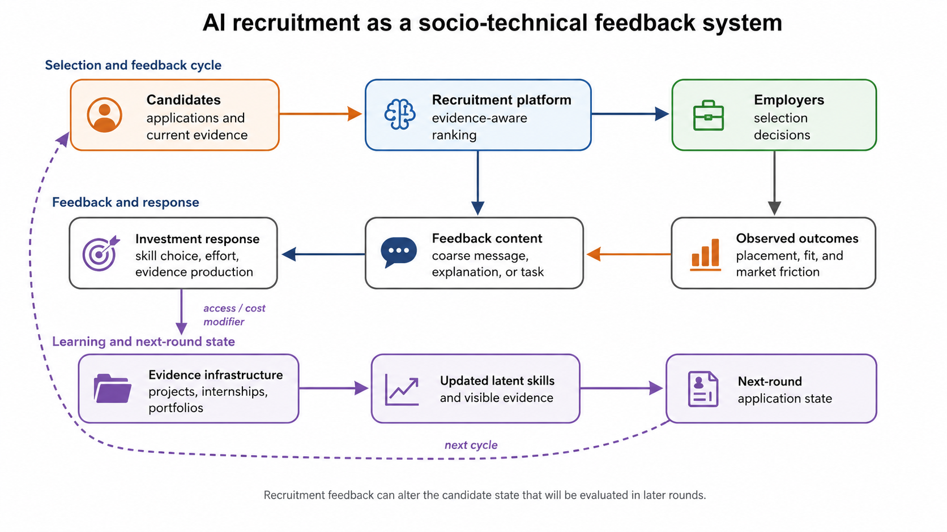
Fig. 1 Socio-technical feedback cycle connecting applications, ranking, employer decisions, returned feedback, candidate investment, evidence-access constraints, and next-round state. Evidence infrastructure modifies access/costs rather than directly granting latent ability.
We develop a computational framework for this mechanism using AdapLink, an evidence-aware talent adaptation system. The paper makes two design choices intended to prevent circular conclusions. First, latent task-relevant ability is separated from the evidence available to the TAI/shortlist ranking rule; the ranking model cannot define its own success criterion. Simulated employers nevertheless receive an imperfect post-shortlist performance proxy, described in Section 3.5, so latent ability is not assumed to be wholly invisible to the final hiring stage. Second, evidence ranking, explanation, and active development are introduced sequentially in four regimes so their effects are not bundled.
The main analysis is a controlled stochastic agent-based model (ABM), rather than an LLM-native simulation. This choice makes the behavioral and institutional assumptions explicit and permits exact replication. Society initialization is benchmark-informed: it matches published aggregate design constraints from a public candidate-job matching dataset (4:1 candidate-job ratio, 24 roles, 10 industries, 73 skills, three seniority levels, and average skill counts) [26] without fitting behavioral parameters to record-level outcomes. Forty paired seeds generate cloned societies that differ only in the recruitment regime. A historical open-data TAI proxy experiment is documented in Supplementary Note S1 for implementation context, but it is not part of the confirmatory evidentiary chain in this article.

1.1 Research questions
RQ1. Does evidence-aware ranking improve latent candidate-job fit and reduce search friction relative to credential/text screening?
RQ2. How dependent is the simulated decline in credential sensitivity on the evidence-confidence discount rule used by employers?
RQ3. Does explanatory feedback alter how candidates allocate skill investment beyond the R1 evidence-ranking/information-set intervention?
RQ4. Do active learning-path tasks create additional realized skill and evidence gains beyond explanation alone?
RQ5. Does evidence-aware recruitment narrow or widen the resource-linked placement gap between candidates with high and low initial access to evidence-generating resources?

1.2 Contributions
The article contributes in four ways. First, it reframes AI recruitment as a socio-technical feedback institution connecting selection, learning, signal production, and later allocation. Second, it distinguishes latent ability, visible skill claims, and evidence credibility so that TAI/shortlist ranking is not evaluated by the same representation it optimizes, while explicitly modeling the employer's imperfect post-shortlist performance signal. Third, it estimates the evidence-ranking/information-set intervention, explanatory-feedback, and active-task effects in a controlled multi-round labor market with neutral controls and paired societies. Fourth, it isolates a model-generated risk pathway in which unequal access to evidence-generating resources can widen a resource-linked placement gap even when the resource-learning channel is switched off; this is a falsifiable mechanism hypothesis for empirical research, not a measured labor-market effect.

2 AI recruitment as a socio-technical feedback institution

2.1 Feedback institutions and performative adaptation
A socio-technical system cannot be understood from the technical artifact alone because outcomes emerge from interactions among computational rules, organizational actors, and users [27]. Recruitment AI is therefore modeled here as a feedback institution: an information rule ranks candidates; employers act on that ranking; the platform returns feedback; candidates adapt skill investment and evidence production; and the changed candidate state enters the next allocation round. This differs from a static person-job fit problem because the system helps produce part of the future input it will later evaluate.
This framing connects three established ideas. First, algorithmic systems reorganize organizational control and evaluation by recording, rating, recommending, and rewarding particular forms of behavior [28, 29]. Second, public measures and rankings can be reactive: actors change behavior because they are evaluated, thereby recreating the social environment measured by the system [30]. Third, performative prediction formalizes the broader point that predictions used for decisions can alter the outcome-generating distribution itself [31]. In recruitment, explanations and development tasks provide an especially direct adaptation channel, making candidate investment and evidence formation endogenous to platform design.

2.2 Signaling and evidence-aware hiring
Employers cannot fully observe productivity before hiring and therefore rely on visible signals such as education, school, major, certificates, work history, and interview performance [1, 4]. Occupational skill requirements contain information beyond broad credentials [5], and recent work has emphasized the distributional consequences of skills, degrees, and algorithmic credential use [6, 8, 9]. Evidence-aware recruitment changes the information set: the same claimed skill can carry different weight depending on whether it is supported by a course project, internship artifact, competition result, portfolio, or other verifiable experience.
Importantly, evidence credibility is not identical to latent ability. A strong candidate may lack opportunities to generate portfolio evidence, while a resource-rich candidate may be better able to make similar ability legible. Treating evidence as an observable signal rather than a ground-truth productivity measure allows the model to examine both information gains and new forms of inequality.

2.3 Explanation as an information intervention
A binary rejection provides little information about the expected return to different learning actions. Explainable matching can instead decompose a result into covered requirements, missing skills, and weakly evidenced skills [14, 16]. Under human-capital theory, this information can change the perceived return to targeted learning [2]. We therefore distinguish an explanation regime from an active development regime. R2 changes information but does not mechanically grant ability. R3 additionally offers a task that may be refused and whose realized gain is stochastic.

2.4 Evidence access and the resource-linked placement gap
Skills-based hiring need not be distributionally neutral. Access to internships, research projects, competitions, mentoring, equipment, and portfolio-building opportunities affects how cheaply candidates can convert ability into visible evidence. We use evidence-access advantage to describe this upstream difference in the ability to generate credible observable evidence. The primary distributional outcome, however, is a distinct downstream quantity: the resource-linked placement gap, defined as the final placement rate of candidates in the top quartile of initial resource access minus the corresponding rate in the bottom quartile within the same seeded society. The revised structural design separately switches resource effects on evidence production, latent learning, and school/credential signals, allowing the simulation to test whether a placement gap can arise through the evidence channel alone. Both constructs are model-generated mechanisms rather than externally measured labor-market elasticities.

2.5 Pre-specified propositions
Table 1 Run-pre-specified propositions and falsification conditions
Proposition | Expected pattern | Decision rule
H1 Evidence-ranking / information-set intervention | R1-R3 increase ground-truth fit and reduce search/vacancy friction relative to R0. | A fit increase without lower friction is only partial support.
C1 Credential sensitivity (construct check) | Sensitivity changes under the baseline evidence-confidence discount rule. | Not part of the confirmatory family; structural discount controls determine interpretation.
H3 Explanation | R2 increases targeted investment and realized latent-gap reduction relative to R1. | Not supported if investment allocation is unchanged.
H4 Active development | R3 increases realized gap reduction and evidence conversion beyond R2. | Not supported if active tasks add no realized gains.
RQ5 Resource-linked placement gap | Direction is exploratory; evidence/learning/credential channel decomposition is required. | Report as a model-generated risk pathway, not an empirical labor-market effect.

3 Methodological framework

3.1 Measurement architecture
Let $K=\{k_{1},…,k_{n}\}$ be a common skill space. Candidate i has latent ability $a_{i}$, observable skill claims $s_{i}$, and evidence credibility $c_{i}$. Job j has demand vector $d_{j}$. The evidence-aware observed representation is
${\tilde{s}}_{i}=s_{i}×c_{i}$ (1)
The TAI/shortlist ranking system observes $s_{i}$ and $c_{i}$ but not $a_{i}$. Ground-truth fit (GTF) is defined from latent ability and job demand as an evaluation benchmark. At the final employer-choice stage, however, the simulated employer receives a noisy task/interview performance proxy generated from GTF; thus latent ability remains unavailable to TAI ranking but is not assumed to be completely uninformative to employers.
GTFij=1−k​max​djk−aik,0k​djk+ϵ (2)
This architecture prevents the evidence-aware TAI/shortlist rule from being evaluated using the same evidence-weighted representation that it optimizes. The noisy performance proxy is shared across all regimes and therefore does not create regime-specific access to the latent benchmark.
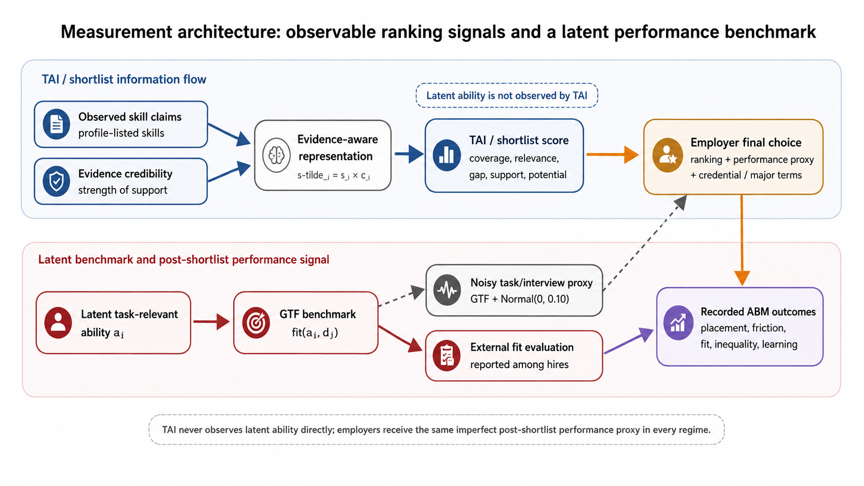
Fig. 2 Information flow separating evidence observed by TAI/shortlist ranking from the latent performance benchmark. TAI does not observe latent ability directly; final employer choice receives a common noisy task/interview proxy, while GTF is retained for external fit evaluation.

3.2 Evidence-aware TAI signal
AdapLink represents skills as a co-occurrence graph and summarizes observable compatibility through five interpretable TAI dimensions: Coverage, Relevance, Gap, Support, and Potential. In the executed ABM, the trained neural TAI is not re-estimated inside every society. Instead, a frozen TAI-style evidence score is used as an institutional signal: weighted overlap between job demand and evidence-weighted skill claims, augmented by evidence support, observed skill overlap, adjacent potential, industry alignment, and seniority compatibility. Latent ability never enters this score.
Table 2 TAI dimensions used to organize evidence-aware information
Dimension | Computational meaning | User interpretation
Coverage | Observed job requirements covered by candidate skills | Requirements already met
Relevance | Structural alignment of candidate and job skill profiles | Overall reason for fit
Gap | Required skills weak or missing in the observed profile | What to improve next
Support | Credibility of experience-based evidence | Claimed versus demonstrably supported skills
Potential | Adjacent or transferable observed capability | Possible development capacity

3.3 Four recruitment regimes
Table 3 Sequential recruitment regimes
Regime | Shortlist rule | Student feedback | Primary contrast
R0 Credential baseline | Keyword overlap + major/industry + school signal + seniority | Coarse pass/reject feedback | Baseline
R1 Evidence ranking | TAI-style evidence-aware ranking; credentials remain visible at final employer decision | Same coarse feedback as R0 | R1-R0: ranking/information-set effect
R2 Explanation | Same ranking and employer interface as R1 | TAI gap/weak-evidence explanation | R2-R1: explanation effect
R3 Active task | Same as R1 | R2 explanation + optional verifiable development task | R3-R2: active-task effect

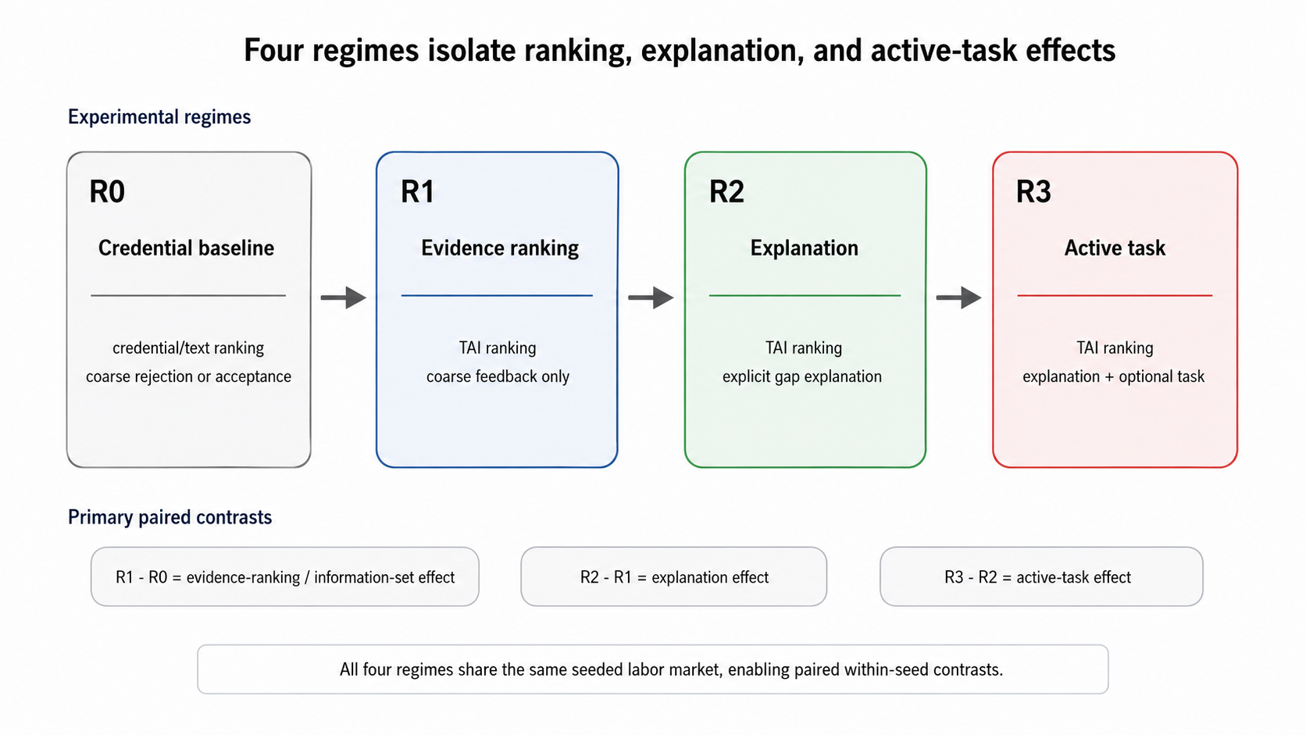
Fig. 3 Sequential recruitment regimes and their primary paired contrasts; R1-R0 changes both evidence-aware ranking and the information set available at shortlist.

3.4 Benchmark-informed structural initialization
The main ABM uses no private applicant records. Its benchmark-informed structural initialization follows the public MIT-licensed Candidate-Job Matching Synthetic Dataset [26], which reports 10,000 resumes, 2,500 jobs, a 4:1 supply-demand ratio, 24 roles, 10 industries, 73 unique skills, balanced junior/mid/senior levels, an average of 6.5 skills per resume, and 5.0 skills per job. The simulation generates fresh microstates that satisfy these published aggregate design constraints. It does not fit behavioral parameters to record-level benchmark outcomes and should therefore not be interpreted as an empirical reconstruction or calibration of that dataset.
Each paired seed contains 120 candidates and 30 jobs, preserving the 4:1 ratio. Role prototypes contain six core skills; jobs draw four to seven required skills around a mean of five. Candidate active-skill counts are drawn around a mean of 6.5. Seniority is balanced across three levels. Resource access is a continuous latent endowment. In the baseline model it can affect evidence credibility/update and learning through separately parameterized gradients; school/credential signals can also correlate with resource access. The structural robustness design independently switches these three channels on and off, so the evidence-resource pathway is not inferred from a model in which resource necessarily changes latent learning.

3.5 Employer and candidate decisions
Candidates submit up to three applications per round using a stochastic utility based on perceived skill overlap, role/industry affinity, seniority feasibility, wage value, target-job preference, and observable evidence. Employers shortlist at most five applicants. R0 shortlist scores weight keyword overlap, major/industry alignment, school signal, and seniority; R1-R3 use the frozen evidence-aware signal. Final employer choice combines a noisy task/interview performance proxy $z_{ij}$, shortlist score $r_{ij}$, school signal, and role/major match: ${score}_{ij}=\frac{0.48z_{ij}+0.30r_{ij}+w_{cred} {school}_{i}+w_{major} {major}_{ij}}{0.78+w_{cred}+w_{major}}$. The performance proxy is $z_{ij}=clip​\left({GTF}_{ij}+N\left(0,0.10\right),0,1\right)$, representing an imperfect structured interview, work-sample test, or job-relevant skills assessment observed after shortlisting. It is generated by the same function in all regimes and is never available to the TAI/shortlist rule. Employer credential priors $p_{j}$ are drawn from $Beta\left(2.3,4.7\right)$, rescaled to the requested mean 0.33, and clipped to [0.03,0.80]. Evidence confidence $q_{ij}$ equals $0.18+0.25 \left(keyword overlap\right)$ in R0 and $clip​\left[0.10+0.75 \left(evidence support\right)+0.15 \left(evidence overlap\right),0,1\right]$ in R1-R3. The school and major weights are $w_{cred}=\frac{p_{j}}{1+λ_{c}q_{ij}}$, $λ_{c}=2.0$, and $w_{major}=\frac{0.12}{1+λ_{m}q_{ij}}$, $λ_{m}=1.3$. Because this functional form directly induces credential substitution, credential sensitivity is treated as a construct check; 20-seed controls vary both discount strengths proportionally from zero to strong discounting.
Each job has two positions across the six-round horizon. At most one candidate is hired by a job in a given round. Hired candidates leave the market; unfilled capacity persists. Employer and student stochastic choices use fixed seed-specific random streams. The model records application, shortlist, hire, learning, and round-state events.

3.6 Learning, explanation, and evidence formation
Unemployed candidates invest after each round. Under R0-R1, learning is weakly targeted. Under R2, candidates may accept an explanation and direct most effort to the largest observed target-job gap. Under R3, candidates can additionally accept an active development task. Learning quality and uptake remain stochastic. Resource dependence is separated from intervention content: the learning multiplier is centered at the baseline resource=0.5 level and multiplied by an independently switchable resource-learning gradient $ρ_{L}$. Evidence credibility has its own independently switchable resource gradient. A completed R3 task with quality at or above 0.55 creates a verifiable artifact by design; evidence conversion is therefore a first-stage intervention outcome, whereas downstream placement and fit remain emergent market outcomes.
Guidance and evaluation deliberately use different information. R2/R3 target the largest gap computed from observable claims weighted by evidence credibility, whereas targeted-investment alignment is scored against the largest latent-ability gap, which the platform cannot observe. Alignment is therefore not mechanically defined by the intervention label; it measures whether an observable recommendation coincides with the hidden task-relevant deficit.
$a_{i,t+1}=clip​\left[a_{i,t}+{learning_rate}_{r}×{quality}_{i,t}×m_{r}​\left({resource}_{i};ρ_{L}\right)+{noise}_{i,t}\right]$ (3)

3.7 Inference, integrity checks, and sensitivity analysis
The treatment is assigned at the cloned-society level, so individual applications are not independent treatment units. The main experiment uses 40 independent paired seeds (1000-1039), each run under R0-R3 for six rounds. Primary inference therefore uses paired run-level differences. For run-level outcome Y, the sequential contrasts are
$Δ_{1}={mean}_{s}​\left(Y_{R1,s}−Y_{R0,s}\right), Δ_{2}={mean}_{s}​\left(Y_{R2,s}−Y_{R1,s}\right), Δ_{3}={mean}_{s}​\left(Y_{R3,s}−Y_{R2,s}\right)$ (4)
For a paired contrast a-b, let $d_{s}=Y_{a,s}−Y_{b,s}$. We report $Δ={mean}_{s}\left(d_{s}\right)$, a 95% t interval over the independent seed-level differences, $MCSE=\frac{sd\left(d_{s}\right)}{\sqrt{n}}$, and paired Cohen $d_{z}=\frac{Δ}{sd\left(d_{s}\right)}$. Event logs are used for mechanism summaries but do not inflate the number of independent treatment assignments. For the 2 × 2 × 2 resource-channel design, the seed-level evidence main effect is the average over L and C of $d_{s}\left(E=1,L,C\right)−d_{s}\left(E=0,L,C\right)$; $E×L$ and $E×C$ are the corresponding within-seed difference-in-differences, averaged over the remaining factor. Pre-run integrity checks verify exactly 40 seeds per regime, no candidate hired twice within a seed/regime, job capacity never above two hires, all rounds within 1-6, and all key outcome ranges.
The confirmatory multiplicity family contains eight contrasts fixed in the simulation protocol before the reported seed batches were run: H1 fit, placement, and search time; H3 investment alignment and total gap reduction; and H4 gap reduction, evidence conversion, and placement. These contrasts were run-pre-specified but were not externally preregistered. Holm correction is applied across the eight tests. The credential-sensitivity construct check and exploratory resource-linked placement-gap RQ5 are reported separately rather than included in the family.
Robustness analysis separates seed uncertainty from structural uncertainty. In addition to the six one-factor sensitivity settings reported in Supplementary Table S3, a 2 × 2 × 2 factorial structural design uses 10 paired seeds per cell and independently toggles (i) the resource-to-evidence gradient E, (ii) the resource-to-learning gradient L, and (iii) resource correlation with the school/credential signal C. The full eight-cell results are reported in Supplementary Table S4, and direct paired factorial estimands for E, E × L, and E × C are reported in Supplementary Table S5. A focused credential-weight diagnostic uses 20 paired seeds under no, half, baseline, and strong evidence-confidence discount functions. A final-hiring institution check uses 20 paired seeds to vary post-shortlist proxy noise (0.05/0.20 versus 0.10 baseline) and hiring threshold (0.46/0.52 versus 0.49 baseline); these runs test whether the headline quality-friction trade-off is tied to one final-employer configuration. RQ5 is exploratory and is not included in the confirmatory multiplicity family.
To separate first-stage manipulation from downstream effects, R2-random replaces largest-gap guidance with random job-relevant guidance and R3-random replaces the targeted task with a random job-relevant task while preserving intervention intensity. These diagnostics use the fixed seed subset 1000-1019 (20 paired seeds); Supplementary Tables S7-S8 report the neutral-control and task-balance estimates, and Supplementary Table S9 reports 5/10/15/20-seed convergence and Monte Carlo standard errors. For R3 versus R3-random, acceptance, completion, accepted-task quality, and accepted-task resource composition are checked at the seed level. Allocation-level realized fit per available position is reported so hire-conditional fit is not interpreted without market-clearing context.
Operational definitions are fixed at the run level unless otherwise stated. The resource-linked placement gap is final placement in the initial-resource Q4 group minus final placement in Q1, with quartile cut points computed inside each seeded base society before treatment and then held common across its cloned regimes. Credential sensitivity is an end-of-run within-profile audit: for each candidate-target pair, the school signal is counterfactually inverted while all other components are held fixed, and the absolute change in deterministic hiring propensity is averaged across candidates. Targeted investment alignment is the mean event-level share of learning effort assigned to the latent largest-gap skill for the candidate's current target job. Aggregate realized fit per available position is the sum of GTF over all hires divided by the 60 available positions in a run. Total latent gap reduction compares each candidate's initial and final gap to the same initial target job; weak-to-verifiable evidence conversion is the horizon-end share of initially weak (<0.40) required skills reaching credibility ≥0.55. Appendix A.6 summarizes these estimands and averaging levels.
The model description follows the ODD protocol [21]. Appendix A provides the process schedule, exact decision functions, random distributions, parameter values, and resource-channel switches. The accompanying replication archive contains the executable model, run scripts, main and robustness outputs, metadata, integrity checks, and a version-pinned requirements file. AgentSociety 2 [22] was considered as an LLM-native extension, but the reported numerical results intentionally use a controlled Python ABM so that they do not depend on a proprietary LLM endpoint or prompt/model version.

3.8 AI-assisted research workflow
A large language model was used to assist manuscript restructuring, code drafting, language refinement, and consistency checking. It was not treated as an author or as a source of numerical results. All reported simulation numbers were generated by executable Python scripts from archived seeds and parameters, exported to CSV, and checked against the run-level outputs. Human authors remain responsible for the model assumptions, source verification, interpretation, and final submitted text, consistent with Elsevier guidance on generative AI in scientific writing.

4 Simulation results

4.1 Evidence-aware ranking improves fit but increases friction
Table 4 Main market outcomes across 40 paired seeds; cells report mean [95% CI]
Outcome | R0 | R1 | R2 | R3
Placement rate | 0.467 [0.462, 0.472] | 0.425 [0.418, 0.432] | 0.425 [0.418, 0.432] | 0.426 [0.418, 0.434]
Ground-truth fit among hires | 0.574 [0.566, 0.583] | 0.604 [0.596, 0.611] | 0.607 [0.600, 0.614] | 0.608 [0.601, 0.615]
Rounds to placement | 1.967 [1.927, 2.006] | 2.168 [2.117, 2.220] | 2.159 [2.111, 2.207] | 2.192 [2.146, 2.238]
Applications per hire | 5.899 [5.780, 6.018] | 6.505 [6.350, 6.660] | 6.478 [6.334, 6.622] | 6.577 [6.439, 6.715]
Job fill rate | 0.935 [0.924, 0.945] | 0.850 [0.836, 0.864] | 0.850 [0.835, 0.864] | 0.852 [0.836, 0.868]
Mean vacancy duration | 2.213 [2.118, 2.309] | 2.944 [2.856, 3.032] | 3.013 [2.920, 3.106] | 2.984 [2.887, 3.081]

The R1 evidence-ranking/information-set intervention raises latent ground-truth fit among hires from 0.574 to 0.604, a paired increase of 0.029 (95% CI 0.025 to 0.034; dz=2.07). However, the same intervention reduces placement by 0.042 (95% CI -0.050 to -0.034) and increases rounds to placement by 0.202 (95% CI 0.141 to 0.262). Fill rate falls by 0.085 and average vacancy duration rises by 0.731 rounds. Because ground-truth fit is conditional on being hired, we also compute an allocation-level diagnostic: aggregate realized fit per available position. On this system-level measure, R1 decreases aggregate realized fit per capacity by 0.024 (95% CI -0.031 to -0.017), confirming that the conditional fit gain is accompanied by lower market clearing.
H1 is therefore only partially supported. The R1 evidence-ranking/information-set intervention selects higher-fit hires, but it does not improve short-run market throughput or aggregate realized fit per available position under the baseline capacity and hiring threshold. The model produces a quality-friction trade-off rather than a universal efficiency gain.
The trade-off is not unique to the baseline final-hiring configuration. Across 20 paired seeds under lower/higher post-shortlist proxy noise and lower/higher hiring thresholds, the R1-R0 conditional-fit effect remains positive (+0.018 to +0.034), placement remains lower (-0.063 to -0.027), and aggregate realized fit per available position remains lower (-0.047 to -0.013). Supplementary Table S10 reports the full intervals. These checks support the direction of the quality-friction trade-off over the tested local institution settings, not universality outside them.
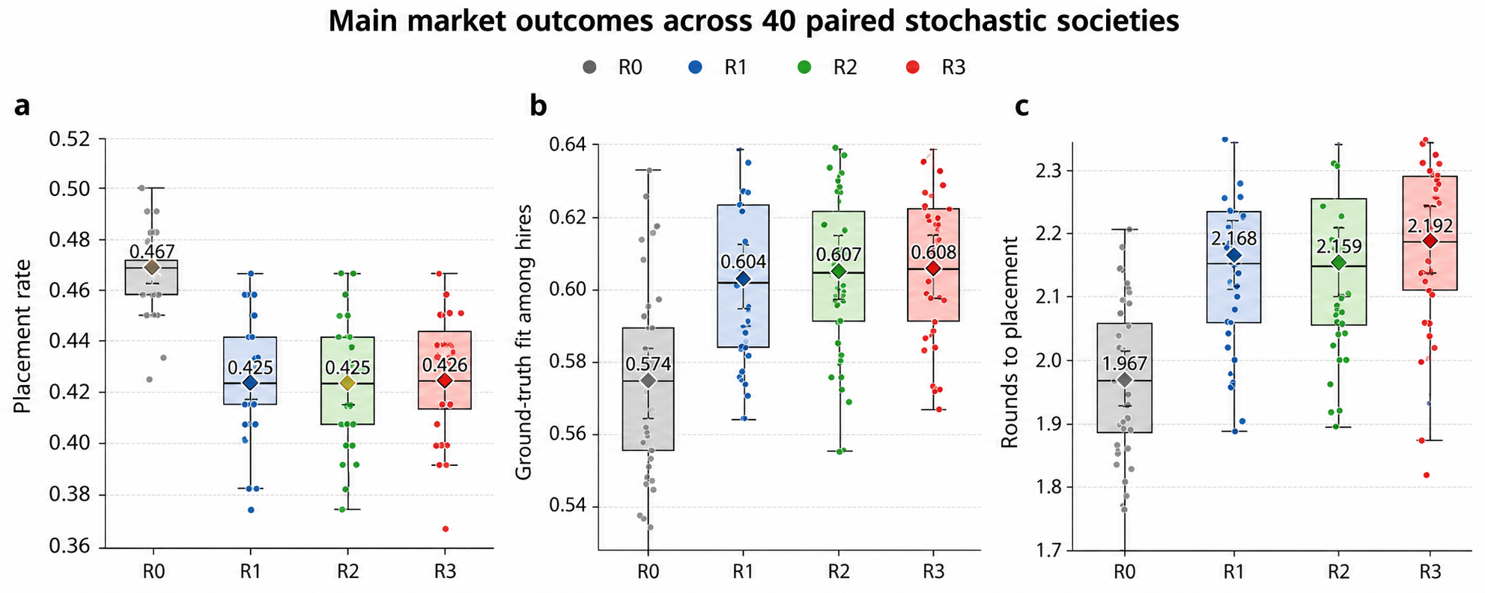
Fig. 4 Market outcomes under R0-R3. Boxplots show the median and interquartile range across 40 independent seeds; jittered dots are individual seeds; diamonds and whiskers show run-level means and 95% confidence intervals. (a) Placement rate, (b) latent ground-truth fit among hires, and (c) rounds to placement.

4.2 Credential sensitivity is construct-dependent; the evidence-resource channel generates a resource-linked placement gap
Table 5 Construct check and resource-linked placement outcome
Outcome | R0 | R1 | R2 | R3
Credential sensitivity | 0.191 [0.185, 0.197] | 0.180 [0.174, 0.186] | 0.163 [0.157, 0.169] | 0.161 [0.156, 0.167]
Resource-linked placement gap (initial-resource Q4 - Q1) | 0.182 [0.149, 0.214] | 0.247 [0.212, 0.281] | 0.223 [0.188, 0.259] | 0.229 [0.189, 0.269]

Under the baseline evidence-confidence discount rule, the within-profile credential audit declines by 0.011 from R0 to R1 (95% CI -0.014 to -0.008). The structural controls show that this decline is not an independent emergent property of evidence-aware ranking. Across 20 paired seeds, the R1-R0 audit change is +0.0084 [0.0041, 0.0128] with no discount, -0.0039 [-0.0080, 0.0001] at half strength, -0.0109 [-0.0148, -0.0069] at baseline strength, and -0.0152 [-0.0191, -0.0114] under strong discounting. We therefore treat credential sensitivity as a construct/manipulation check and exclude it from the confirmatory hypothesis family.
The distributional pattern survives a more demanding channel decomposition. In the 2 × 2 × 2 structural design, when resource access affects evidence production/update but is prevented from affecting latent learning and school/credential signals, the R1-R0 resource-linked placement gap increases by 0.113 (95% CI 0.025 to 0.202; 10 paired seeds). The corresponding learning-only condition is -0.017 [-0.115, 0.082], and the both-off condition is -0.013 [-0.113, 0.087]. Across all eight cells, the R1-R0 gap change ranges from +0.083 to +0.113 when the evidence channel is on and from -0.057 to -0.013 when it is off. More importantly, the direct paired factorial estimand is +0.133 for the evidence-channel main effect (95% CI 0.041 to 0.225; p=0.0096), while E × L is +0.0033 (95% CI -0.0061 to 0.0127; p=0.443) and E × C is +0.010 (95% CI -0.156 to 0.176; p=0.894). Thus the model supports a distinct evidence-resource pathway without detectable moderation by the learning or credential-resource channels in this 10-seed factorial design. The magnitude remains imprecise and is interpreted as a structural risk mechanism, not a real-world inequality estimate.
Group-level decomposition clarifies the allocation mechanism. In the 40-seed baseline comparison, Q1 placement falls from 0.378 to 0.301 (R1-R0 -0.077, 95% CI -0.097 to -0.057), while Q4 placement changes from 0.559 to 0.547 (-0.012, -0.036 to 0.013). Thus the baseline gap widening is concentrated in lower-resource placement loss. Across the full factorial, the direct evidence-channel effect decomposes into a Q1 change of -0.058 (-0.125 to 0.009) and a Q4 change of +0.075 (0.037 to 0.113); this structural averaging is consistent with both disadvantaged-group loss and cumulative advantage, with the Q4 component estimated more precisely. The 10-seed evidence-channel main effect is also robust to an exact two-sided sign-flip test (p=0.0156) and a 50,000-resample paired bootstrap interval [0.057, 0.207] (Supplementary Tables S11-S12).
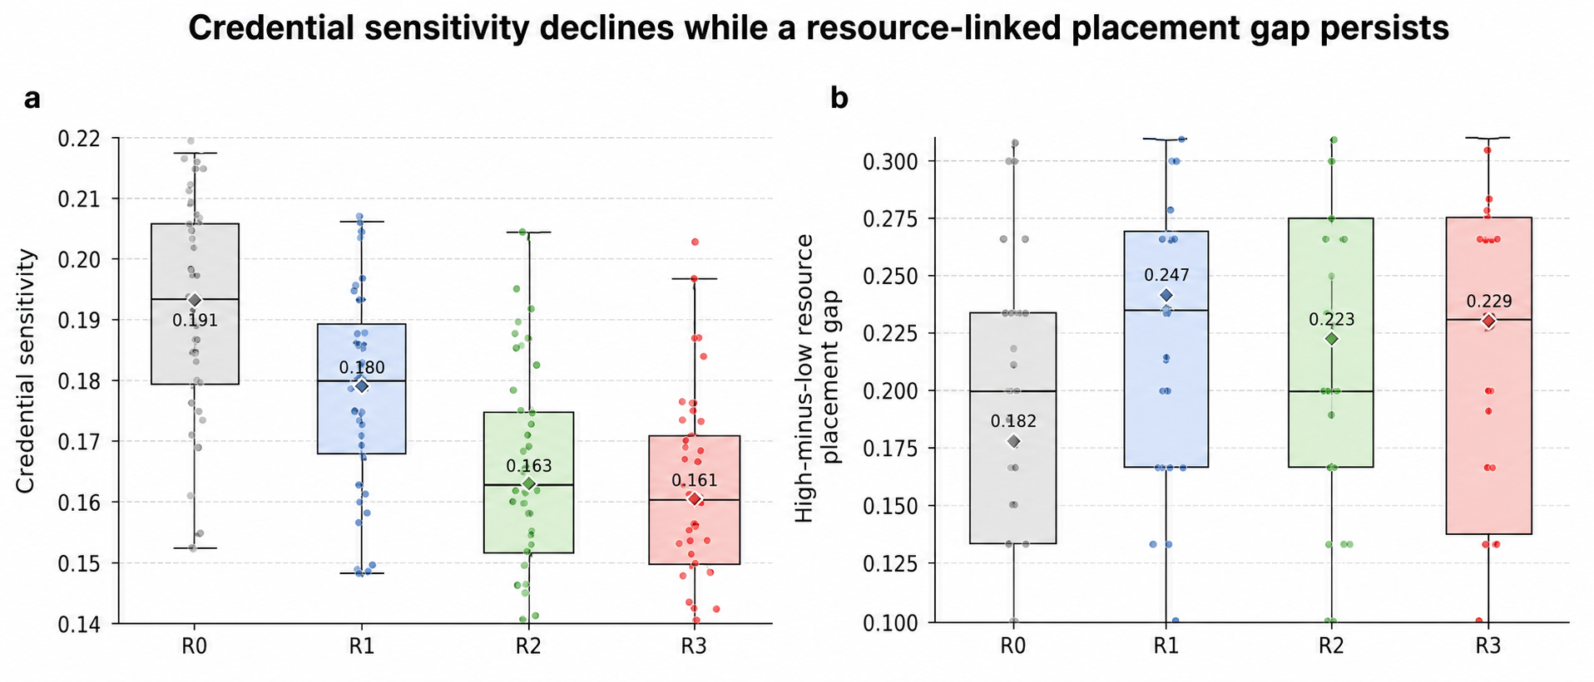
Fig. 5 Credential-sensitivity construct check and exploratory resource-linked placement gap across regimes. Boxplots show seed-level distributions; diamonds and whiskers show run-level means and 95% confidence intervals.

4.3 Explanations reshape investment without immediate placement gains
Table 6 Behavioral shaping outcomes
Outcome | R0 | R1 | R2 | R3
Targeted investment alignment | 0.080 [0.076, 0.084] | 0.079 [0.076, 0.082] | 0.348 [0.342, 0.353] | 0.344 [0.339, 0.348]
Total latent gap reduction | 0.0031 [0.0030, 0.0032] | 0.0034 [0.0033, 0.0035] | 0.0111 [0.0108, 0.0113] | 0.0159 [0.0154, 0.0164]
Weak-to-verifiable evidence conversion | 0 by design (N.A.) | 0 by design (N.A.) | 0 by design (N.A.) | 0.077 [0.072, 0.081]

R2 changes investment behavior sharply. Targeted investment alignment rises by 0.269 relative to R1 (95% CI 0.263 to 0.275), and total latent gap reduction increases by 0.0077 (95% CI 0.0074 to 0.0079). A neutral-control diagnostic replacing target-gap explanations with random job-relevant skill guidance shows that most alignment is not produced by extra learning intensity alone: R2 exceeds the random-guidance control by 0.255 in investment alignment (95% CI 0.246 to 0.263) and by 0.0020 in total gap reduction (95% CI 0.0016 to 0.0025), with no detectable placement or fit change. Yet placement changes by only -0.0002 with a confidence interval crossing zero, and ground-truth fit changes by 0.0036, also not clearly different from zero. Thus H3 is supported for the targeted behavioral first stage and modest latent-gap gains, but not for short-run labor-market outcomes.
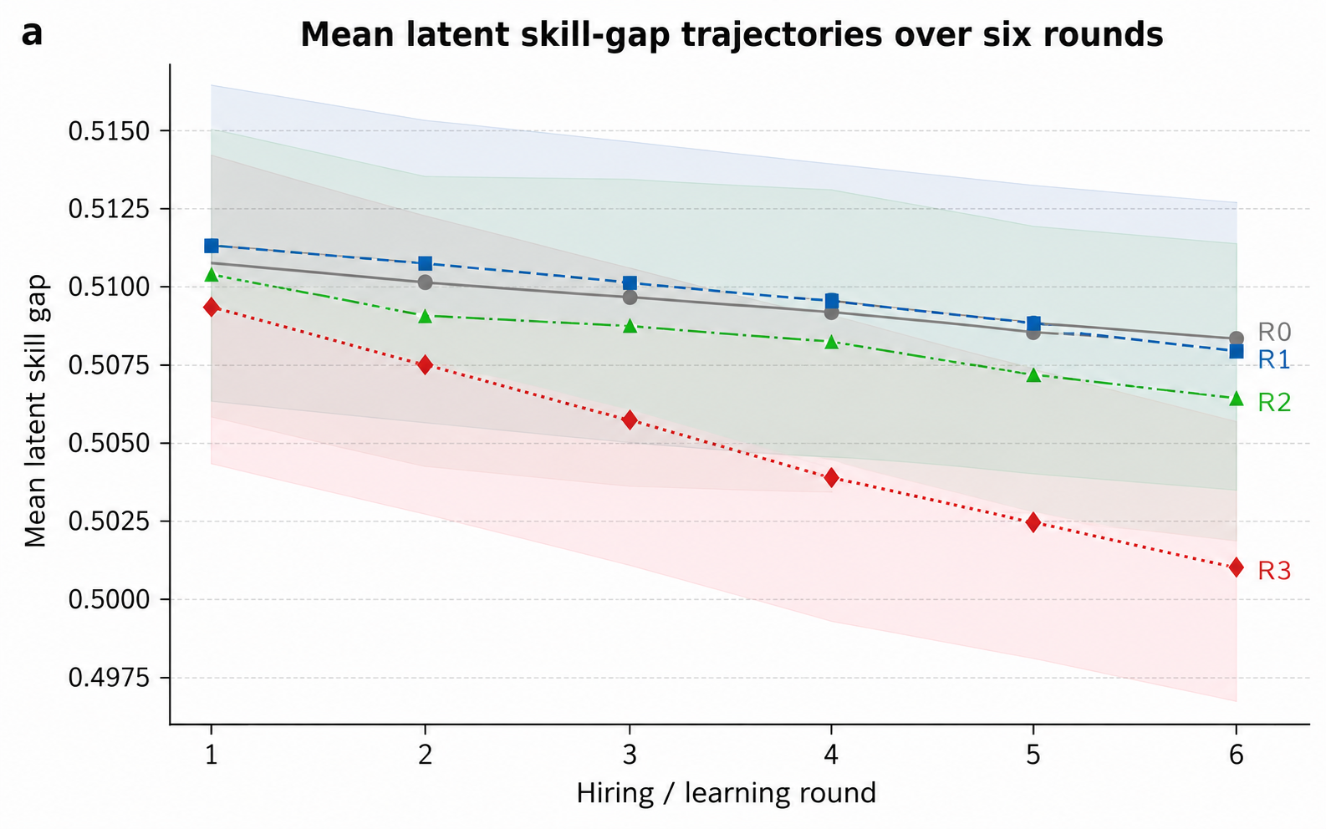
Fig. 6 Mean latent skill-gap trajectories over six rounds. Lines show regime means; shaded bands indicate approximate 95% confidence intervals over run-level means.

4.4 Active tasks deepen skill/evidence formation but do not improve six-round placement
R3 adds an active, optional task to the R2 information environment. Relative to R2, total latent gap reduction increases by 0.0048 (95% CI 0.0043 to 0.0054) and weak-to-verifiable evidence conversion increases by 0.077 (95% CI 0.072 to 0.081). A random-task diagnostic shows that targeted tasks add alignment and gap reduction beyond generic task intensity: R3 exceeds R3-random by 0.243 in investment alignment, 0.0032 in total gap reduction, and 0.023 in evidence conversion. The targeted and random-task conditions are balanced on acceptance (+0.0032, 95% CI -0.0090 to 0.0154), completion (+0.0056, -0.0033 to 0.0145), accepted-task quality (+0.0083, -0.0016 to 0.0182), and accepted-task resource composition (-0.0062, -0.0137 to 0.0013). The additional targeting effect is therefore not explained by observable differences in task take-up, completion, quality, or resource composition within this diagnostic. Evidence conversion remains a first-stage intervention outcome because a successfully completed task is explicitly designed to yield a verifiable artifact.
The behavioral gains do not translate into a detectable six-round placement gain: R3-R2 placement is 0.0012 (95% CI -0.0066 to 0.0091), and the random-task diagnostic similarly shows no reliable placement difference. H4 is therefore supported for targeted skill/evidence formation but not for immediate employment. This temporal separation is substantively useful: algorithmic talent shaping can be present before it becomes visible in market-level outcomes.
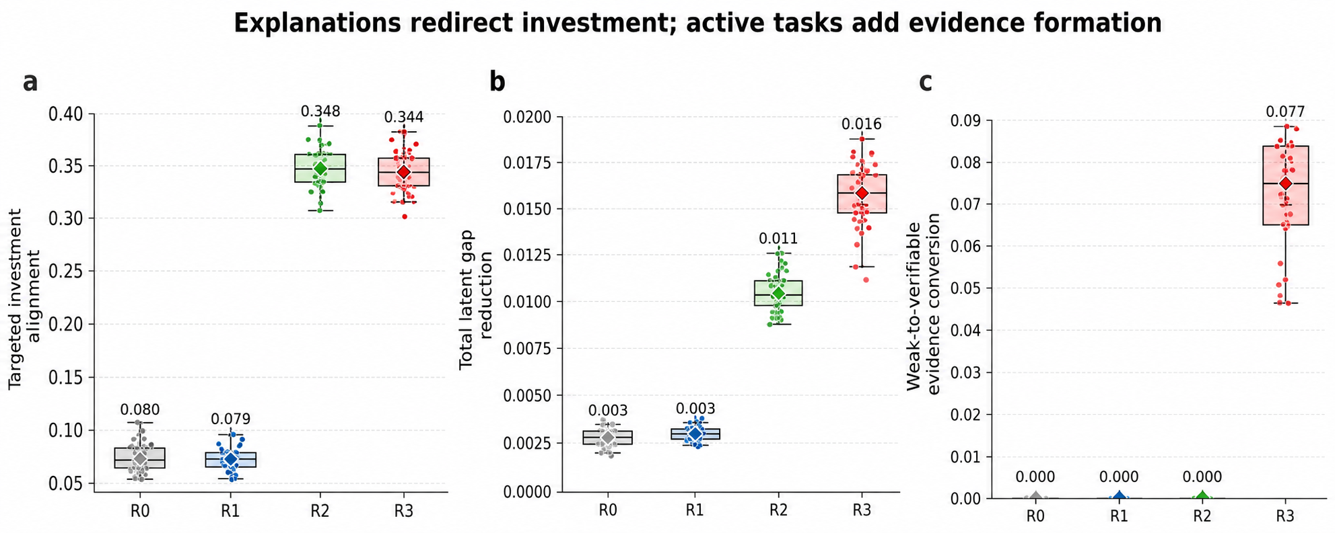
Fig. 7 Behavioral shaping outcomes under R0-R3. Boxplots show the median and interquartile range across 40 independent seeds; jittered dots are individual seeds; diamonds and whiskers show run-level means and 95% confidence intervals. (a) Targeted investment alignment, (b) total latent gap reduction, and (c) weak-to-verifiable evidence conversion.

4.5 Primary paired contrasts and structural robustness
Table 7 Main paired contrasts; n=40 independent seed-level differences. Status distinguishes the eight-test Holm confirmatory family from the credential construct check and exploratory distributional outcome.
Outcome | Contrast | Mean delta | 95% CI | Cohen dz | MCSE | Status / family
Evidence-ranking/information-set: ground-truth fit | R1-R0 | 0.0293 | [0.0248, 0.0338] | 2.07 | 0.0022 | Confirmatory (Holm)
Evidence-ranking/information-set: placement rate | R1-R0 | -0.0423 | [-0.0501, -0.0344] | -1.72 | 0.0039 | Confirmatory (Holm)
Evidence-ranking/information-set: search rounds | R1-R0 | 0.2016 | [0.1409, 0.2622] | 1.06 | 0.0300 | Confirmatory (Holm)
Construct check: credential sensitivity | R1-R0 | -0.0110 | [-0.0137, -0.0083] | -1.31 | 0.0013 | Construct check
Exploratory: resource-linked placement gap | R1-R0 | 0.0650 | [0.0307, 0.0993] | 0.61 | 0.0170 | Exploratory
Explanation: targeted investment | R2-R1 | 0.2692 | [0.2630, 0.2754] | 13.89 | 0.0031 | Confirmatory (Holm)
Explanation: total gap reduction | R2-R1 | 0.0077 | [0.0074, 0.0079] | 8.88 | 0.0001 | Confirmatory (Holm)
Active task: additional gap reduction | R3-R2 | 0.0048 | [0.0043, 0.0054] | 2.86 | 0.0003 | Confirmatory (Holm)
Active task: evidence conversion | R3-R2 | 0.0768 | [0.0724, 0.0811] | 5.59 | 0.0022 | Confirmatory (Holm)
Active task: placement rate | R3-R2 | 0.0012 | [-0.0066, 0.0091] | 0.05 | 0.0039 | Confirmatory (Holm)
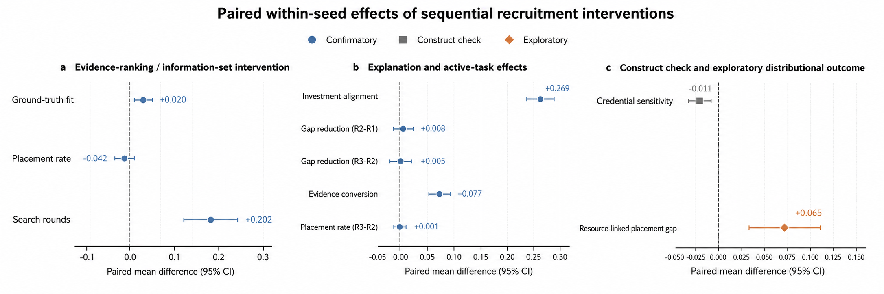
Fig. 8 Paired within-seed effect estimates for the sequential interventions. Points show mean seed-level differences and whiskers show 95% t intervals. Panels separate confirmatory outcomes from the credential construct check and exploratory resource-linked placement-gap outcome.

Table 8 Structural decomposition of the R1-R0 resource-linked placement-gap contrast; n=10 paired seeds per structural cell
Table 8 reports the five most interpretable channel conditions. The complete eight-cell factorial is provided in Supplementary Table S4; the direct evidence-channel main effect and E × L/E × C interactions are reported in Supplementary Table S5. Each structural cell uses the same 10 paired seeds (1000-1009).
Structural condition | Evidence channel | Learning channel | Credential-resource correlation | R1-R0 resource-linked placement-gap delta [95% CI]
Both off | Off | Off | Off | -0.013 [-0.113, 0.087]
Learning only | Off | On | Off | -0.017 [-0.115, 0.082]
Evidence only | On | Off | Off | 0.113 [0.025, 0.202]
Evidence + learning | On | On | Off | 0.113 [0.025, 0.202]
Full baseline | On | On | On | 0.083 [-0.023, 0.190]

The paired main effects remain statistically stable after multiplicity correction. In the eight-test confirmatory family, Holm-adjusted p-values are ≤1.03 × 10⁻⁷ for every run-pre-specified H1/H3/H4 contrast except R3-R2 placement, which remains null (adjusted p=0.748); complete statistics are reported in Supplementary Table S6. Main-effect convergence across the ordered 10/20/30/40-seed sequence preserves the direction and substantive conclusion of all eight confirmatory contrasts, while MCSE declines with additional seeds (Supplementary Table S13). Neutral-control estimates likewise stabilize across 5/10/15/20 seeds (Supplementary Table S9). One-factor sensitivity remains supportive for shaping effects (Supplementary Table S3), the final-hiring institution check preserves the H1 quality-friction direction over the tested proxy-noise/threshold settings (Supplementary Table S10), and the full factorial plus exact sign-flip analysis shows that the resource-linked placement-gap result is specifically contingent on the evidence-resource channel (Supplementary Tables S4-S5 and S12).
Table 9 Additional diagnostics; sample size varies by diagnostic as indicated in the comparison column.
Diagnostic | Comparison | Key result | Interpretation
Allocation-level fit | R1-R0 | Aggregate realized fit per available position: -0.024 [-0.031, -0.017] | Conditional hire quality rises, but lower market clearing reduces system-level realized fit.
Neutral explanation control | R2-R2-random | Investment alignment +0.255 [0.246, 0.263]; total gap reduction +0.0020 [0.0016, 0.0025] | Targeted guidance matters beyond extra learning intensity; placement and fit remain null.
Neutral active-task control | R3-R3-random | Alignment +0.243 [0.234, 0.252]; gap reduction +0.0032 [0.0024, 0.0040]; evidence conversion +0.023 [0.016, 0.030] | Targeting adds skill/evidence formation beyond a random job-relevant task.
Task-balance check | R3-R3-random | Acceptance +0.003 [-0.009, 0.015]; completion +0.006 [-0.003, 0.014]; quality +0.008 [-0.002, 0.018]; resource -0.006 [-0.014, 0.001] | No detectable imbalance in take-up, completion, accepted-task quality, or accepted-user resources.
Multiplicity check | Eight-test Holm family | All run-pre-specified H1/H3/H4 contrasts except R3-R2 placement have Holm-adjusted p ≤ 1.03 × 10⁻⁷; R3-R2 placement adjusted p=0.748 | Confirmatory mechanism contrasts remain significant; immediate placement does not.
Final-hiring institution sensitivity | R1-R0; n=20/scenario | Across proxy-noise/threshold settings: fit +0.018 to +0.034; placement -0.063 to -0.027; aggregate fit -0.047 to -0.013. | Quality-friction direction persists across tested local final-hiring settings.
Resource-group level decomposition | R1-R0; main n=40 | Q1 placement -0.077 [-0.097, -0.057]; Q4 -0.012 [-0.036, 0.013]. | Baseline gap widening is concentrated in lower-resource placement loss.
Distribution-free factorial check | Evidence-channel main effect; n=10 | Exact sign-flip p=0.0156; bootstrap 95% interval [0.057, 0.207]. | The structural evidence-channel conclusion is not an artifact of the t approximation alone.
Main-seed convergence | 10/20/30/40 paired seeds | All eight confirmatory contrasts preserve direction/conclusion; MCSE declines with n. | Supports stability of the 40-seed main estimates.

5 Discussion: social implications of AI recruitment

5.1 AI recruitment can improve fit while increasing market friction
The strongest market-level result is not a simple “AI is better” finding. Under the baseline final-hiring institution, the R1 evidence-ranking/information-set intervention improves the conditional fit of those hired, but it also makes the market harder to clear in the short run. Local sensitivity to post-shortlist proxy noise and hiring threshold preserves the direction of this trade-off, although its magnitude remains institution-dependent. Evidence-aware recruitment can therefore raise conditional match quality while increasing search friction in the tested settings. This matters socially because platforms, universities, and employers may otherwise over-interpret improvements in ranking quality as improvements in the functioning of the labor market itself.
This qualifies common platform narratives that equate better ranking with better labor-market efficiency. For researchers, it suggests that evaluation should report both conditional match quality and system-level clearing outcomes. For product design, it suggests that stricter evidence signals may need complementary policies that expand opportunities to produce evidence or relax thresholds when the market is thin.

5.2 Talent shaping appears first in learning trajectories, not placement rates
The R2 and R3 results separate behavioral shaping from immediate employment. Explanations dramatically change where effort is allocated and increase latent gap reduction, while active tasks add further skill/evidence formation. Yet neither component produces a detectable six-round placement improvement. This is not a nullification of the shaping hypothesis. It indicates a lag between micro-level investment and macro-level hiring outcomes under the specified horizon.
The finding also illustrates why static offline recommendation tests cannot answer the central question. A one-shot benchmark observes who is ranked today. The ABM observes whether feedback changes the state that will be ranked tomorrow. The model therefore complements person-job fit work [12, 13] with a dynamic mechanism rather than claiming a universally superior predictor.

5.3 Resource-linked placement inequality is a model-generated risk pathway
The revised diagnostics separate two claims that should not be conflated. The decline in credential sensitivity is sensitive to the employer discount function and is therefore a construct check, not a general behavioral finding. The upstream mechanism is unequal access to evidence generation; the downstream measured outcome is the resource-linked placement gap. In the main baseline comparison, gap widening is concentrated in a decline in Q1 placement, whereas the factorial evidence-channel decomposition combines a less precise Q1 loss with a more precisely estimated Q4 gain. Thus the same aggregate gap can reflect screening exclusion, cumulative advantage, or both. In the evidence-only structural condition the R1-R0 placement gap widens even when resource effects on latent learning and school/credential signals are switched off, and the direct evidence-channel factorial effect is +0.133 (95% CI 0.041 to 0.225; t-based p=0.0096; exact sign-flip p=0.0156). Within this specified computational society, rewarding visible evidence can therefore generate an opportunity-allocation pathway through unequal ability to produce that evidence.
The result should still be interpreted as a model-generated risk hypothesis. The structural cells use synthetic agents, only 10 paired seeds per factorial cell, and parameter values that are not estimated from real applicant trajectories. The nonsignificant E × L and E × C interactions do not establish zero moderation; they simply indicate that this design does not detect additional interaction effects at the present precision. The simulation identifies a mechanism that can exist, not its empirical prevalence or magnitude. A real-world test would require measuring access to projects, internships, mentoring, and portfolio infrastructure, then estimating whether evidence-aware selection changes resource-linked placement gaps after accounting for latent skill growth and credential signals.

5.4 Implications for education, employers, and technology governance
For platform design, the simulation implies that evaluation should extend beyond ranking accuracy to feedback effects: what information is returned, what behaviors it rewards, and whether it changes the future applicant distribution. This follows the socio-technical and performativity perspective that algorithmic measures can reorganize behavior and institutional practice [27-31]. For universities, the model motivates attention to evidence infrastructure—project access, authentic assessments, portfolios, research opportunities, and low-cost industry tasks—because competence must become legible before an evidence-aware system can reward it. For employers, evidence-aware screening can improve conditional fit but should be monitored for throughput and group-specific placement changes. The Q1/Q4 decomposition matters for governance: a gap driven by Q1 loss points toward exclusion safeguards and alternative evidence routes, whereas a gap driven by Q4 gain points more directly toward equalizing access to evidence-generating opportunities. For public governance, the simulation generates a risk hypothesis rather than a policy prescription: fairness audits may need to examine the costs and opportunities required to generate rewarded evidence, not only whether school labels are explicitly included.

5.5 Limitations
The findings are computational, conditional, and deliberately narrower than real-world causal claims. First, the main population is generated from published aggregate properties of a public synthetic benchmark; it is not a sample of actual applicants. The resource-evidence relationship, employer decision rule, learning rates, task uptake, and capacity are structural assumptions that require empirical calibration. Second, the technical TAI pilot uses proxy labels and cannot establish hiring validity. Third, evidence conversion in R3 is partly a manipulation check because a successful task is defined to generate a verifiable artifact. Fourth, the current ABM uses stochastic rule-based agents rather than LLM-native agents. This improves transparency for the reported causal contrasts but omits richer language-mediated interpretation and preference heterogeneity; a future AgentSociety 2 implementation [22] should be treated as a robustness extension rather than silently substituted for the present results.
External validation should compare simulated application concentration, explanation uptake, target switching, task completion, and longitudinal skill/evidence changes with real platform logs, human-subject experiments, or HR annotations. A minimum prospective test would randomize eligible job seekers to coarse feedback, targeted gap explanations, or targeted development tasks; measure baseline access to projects, internships, mentoring, and portfolio infrastructure; and follow evidence creation, applications, interviews, and placement for a pre-specified horizon. A complementary platform-rollout design could estimate whether evidence-aware ranking changes Q1/Q4 placement differently across cohorts while controlling for baseline skill and credential signals. The distinction between evidence-access advantage and the downstream resource-linked placement gap is particularly important to validate against real differences in access to evidence-generating opportunities. Until such validation is available, numerical effect sizes should be interpreted as properties of the specified computational society, not forecasts of actual applicant and employment outcomes.

6 Conclusion
AI recruitment can affect both who is selected and the information environment in which candidates invest. In this benchmark-informed computational labor market, the R1 evidence-ranking/information-set intervention raises the conditional latent fit of hires but lowers short-run placement, increases search friction, and reduces aggregate realized fit per available position. Explanations and active tasks change learning trajectories and evidence formation without producing a detectable six-round placement gain. Neutral controls show that targeted guidance matters beyond generic additional learning, and task-balance checks rule out simple differences in take-up, completion, quality, or accepted-user resources. Structural channel decomposition and a direct factorial contrast further show that a model-generated resource-linked placement gap can arise through evidence production alone, whereas the simulated decline in credential sensitivity depends strongly on an explicitly specified discount function. The resulting contribution is therefore mechanistic rather than predictive: AI recruitment can be studied as a feedback technology capable of reshaping future signals and opportunity structures, while the empirical size and prevalence of these effects remain questions for real-world validation.

Statements and Declarations

Funding
This research received no specific grant from funding agencies in the public, commercial, or not-for-profit sectors.

Competing interests
The authors declare that they have no known competing financial interests or personal relationships that could have appeared to influence the work reported in this paper.

CRediT authorship contribution statement
Qingyu Luo: Conceptualization, Methodology, Formal analysis, Investigation, Writing - original draft, Writing - review & editing, Project administration. Shiqing Peng: Software, Data curation, Validation, Writing - review & editing.

Ethics statement
The reported main ABM uses generated synthetic agents and public benchmark statistics; the technical pilot uses open/anonymized resume-derived data. No intervention involving identifiable human participants is reported in this manuscript. Any future validation involving real students, employers, questionnaires, or identifiable platform logs should receive appropriate ethics review and consent where required.

Data availability
Benchmark-informed initialization uses the MIT-licensed Candidate-Job Matching Synthetic Dataset [26] only for published aggregate design constraints; record-level benchmark files are not redistributed. All analysis-ready run-level, round-level, learning-event, hire-event, neutral-control, structural-control, task-balance, and diagnostic outputs used in this manuscript are included in the reviewer-accessible replication archive supplied with the submission. The historical Tianchi proxy pilot is documented separately in Supplementary Note S1; access to the source competition page may require platform login [25].

Code availability
The reviewer-accessible replication archive supplied with this submission contains the executable Python model, exact parameters, structural-control scripts, integrity checks, analysis-ready outputs, requirements.txt, an MIT software license, and main/revision verification commands. A persistent public release (for example, Zenodo/OSF or an archived Git repository) will be created at acceptance or earlier if required by the editor.

Declaration of generative AI and AI-assisted technologies in the writing process
During the preparation of this work, the authors used AI-assisted tools to support language refinement, manuscript restructuring, code drafting, and internal consistency checking. All numerical analyses, simulations, and figure source data were verified by the authors, who take full responsibility for the content of this article.

References
[1] Spence, M. (1973). Job market signaling. The Quarterly Journal of Economics, 87(3), 355-374. https://doi.org/10.2307/1882010
[2] Becker, G. S. (1964). Human capital: A theoretical and empirical analysis, with special reference to education. University of Chicago Press.
[3] Edwards, J. R. (1991). Person-job fit: A conceptual integration, literature review, and methodological critique. In C. L. Cooper & I. T. Robertson (Eds.), International Review of Industrial and Organizational Psychology (Vol. 6, pp. 283-357). Wiley.
[4] Pallais, A. (2014). Inefficient hiring in entry-level labor markets. American Economic Review, 104(11), 3565-3599. https://doi.org/10.1257/aer.104.11.3565
[5] Deming, D. J., & Kahn, L. B. (2018). Skill requirements across firms and labor markets: Evidence from job postings for professionals. Journal of Labor Economics, 36(S1), S337-S369. https://doi.org/10.1086/694106
[6] Blair, P. Q., Debroy, P., & Heck, J. (2025). Skills, degrees and labor market inequality. Economics of Education Review, 108, 102704.
[7] Conzelmann, J. G., Hemelt, S. W., Hershbein, B., Martin, S. M., Simon, A., & Stange, K. M. (2023). Skills, majors, and jobs: Does higher education respond? NBER Working Paper 31572. https://doi.org/10.3386/w31572
[8] Blair, P. Q., & Guo, R. (2026). Algorithmic credentialism. NBER Working Paper 35192. https://doi.org/10.3386/w35192
[9] Deming, D. J., & Silliman, M. I. (2024). Skills and human capital in the labor market. NBER Working Paper 32908. https://doi.org/10.3386/w32908
[10] Kochling, A., & Wehner, M. C. (2020). Discriminated by an algorithm: A systematic review of discrimination and fairness by algorithmic decision-making in HR. Business Research, 13, 795-848. https://doi.org/10.1007/s40685-020-00134-w
[11] Kassir, S., Baker, L., Dolphin, J., & Polli, F. (2023). AI for hiring in context: A perspective on overcoming the unique challenges of employment research to mitigate disparate impact. AI and Ethics, 3, 845-868. https://doi.org/10.1007/s43681-022-00208-x
[12] Zhu, C., Zhu, H., Xiong, H., et al. (2018). Person-job fit: Adapting the right talent for the right job with joint representation learning. ACM Transactions on Management Information Systems, 9(3), Article 12. https://doi.org/10.1145/3234465
[13] Qin, C., Zhu, H., Xu, T., Zhu, C., Jiang, L., Chen, E., & Xiong, H. (2018). Enhancing person-job fit for talent recruitment: An ability-aware neural network approach. Proceedings of SIGIR, 25-34. https://doi.org/10.1145/3209978.3210025
[14] Zhang, Y., & Chen, X. (2020). Explainable recommendation: A survey and new perspectives. Foundations and Trends in Information Retrieval, 14(1), 1-101. https://doi.org/10.1561/1500000066
[15] Kipf, T. N., & Welling, M. (2017). Semi-supervised classification with graph convolutional networks. International Conference on Learning Representations. https://arxiv.org/abs/1609.02907
[16] Lundberg, S. M., & Lee, S.-I. (2017). A unified approach to interpreting model predictions. Advances in Neural Information Processing Systems, 30, 4765-4774.
[17] Lukac, M., & Grow, A. (2021). Reputation systems and recruitment in online labor markets: Insights from an agent-based model. Journal of Computational Social Science, 4, 207-229. https://doi.org/10.1007/s42001-020-00072-x
[18] Hashimoto, R., Takayanagi, T., Suzuki, M., et al. (2026). LLM agents reveal how human bias shapes path-dependent market dynamics. Journal of Computational Social Science, 9, Article 32. https://doi.org/10.1007/s42001-026-00465-4
[19] Gelling, J., Urman, A., & Hannak, A. (2026). Auditing the bias of conversational AI systems in occupational recommendations: A novel approach to bias quantification via Holland’s theory. Journal of Computational Social Science, 9, Article 6. https://doi.org/10.1007/s42001-025-00433-4
[20] Larooij, M., & Tornberg, P. (2026). Validation is the central challenge for generative social simulation: A critical review of LLMs in agent-based modeling. Artificial Intelligence Review, 59, Article 15. https://doi.org/10.1007/s10462-025-11412-6
[21] Grimm, V., Railsback, S. F., Vincenot, C. E., et al. (2020). The ODD protocol for describing agent-based and other simulation models: A second update to improve clarity, replication, and structural realism. Journal of Artificial Societies and Social Simulation, 23(2), 7. https://doi.org/10.18564/jasss.4259
[22] Piao, J., Zhang, J., Huang, H., et al. (2026). AgentSociety 2: An integrated research environment for executable social science. arXiv:2607.11895. https://doi.org/10.48550/arXiv.2607.11895
[23] European Commission. (n.d.). ESCO: European Skills, Competences, Qualifications and Occupations. https://esco.ec.europa.eu/
[24] National Center for O*NET Development. (n.d.). O*NET OnLine. https://www.onetonline.org/
[25] Alibaba Cloud Tianchi. (n.d.). Talent dataset and talent knowledge graph competition data description. https://tianchi.aliyun.com/competition/entrance/231771/information
[26] Ozon, M. (2026). Candidate-Job Matching Synthetic Dataset (Version 1.0.0) [Data set]. Hugging Face. https://huggingface.co/datasets/michaelozon/candidate-matching-synthetic
[27] Baxter, G., & Sommerville, I. (2011). Socio-technical systems: From design methods to systems engineering. Interacting with Computers, 23(1), 4-17. https://doi.org/10.1016/j.intcom.2010.07.003
[28] Kellogg, K. C., Valentine, M. A., & Christin, A. (2020). Algorithms at work: The new contested terrain of control. Academy of Management Annals, 14(1), 366-410. https://doi.org/10.5465/annals.2018.0174
[29] Beer, D. (2017). The social power of algorithms. Information, Communication & Society, 20(1), 1-13. https://doi.org/10.1080/1369118X.2016.1216147
[30] Espeland, W. N., & Sauder, M. (2007). Rankings and reactivity: How public measures recreate social worlds. American Journal of Sociology, 113(1), 1-40. https://doi.org/10.1086/517897
[31] Perdomo, J., Zrnic, T., Mendler-Dünner, C., & Hardt, M. (2020). Performative prediction. Proceedings of the 37th International Conference on Machine Learning, PMLR 119, 7599-7609.

Appendix A ODD-style implementation summary and exact baseline parameters
Table A1 Exact baseline parameters used for the reported ABM
Parameter | Value | Status / rationale
Population | 120 candidates; 30 jobs; 73 skills; 24 roles; 10 industries | Benchmark-informed structural initialization [26]
Horizon | 6 rounds | Pre-specified design
Applications | Max 3 per unemployed candidate per round | Fixed rule
Shortlist | Top 5 applicants per job | Fixed rule
Capacity | 2 hires per job across horizon; max 1 hire/job/round | Fixed rule
Resource-evidence coupling | 0.55 | Baseline assumption; 0.30/0.72 in sensitivity
Explanation uptake | 0.67 x readiness modifier | 0.45/0.82 sensitivity values
Active-task acceptance | 0.58 x readiness modifier | Baseline assumption
Generic learning rate | 0.035 | Baseline assumption
Explanation-guided learning rate | 0.072 | Baseline assumption
Active-task learning rate | 0.120 | Baseline assumption
Self-study evidence gain scale | 0.025 | Baseline assumption
Active-task evidence gain scale | 0.165 | Baseline assumption
Interview/task-signal noise | 0.10 | Baseline assumption
Hiring threshold | 0.49 | Baseline assumption
Hiring temperature | 0.06 | Stochastic logistic choice
Employer credential-prior mean | 0.33 | 0.20/0.48 sensitivity values
Choice temperature | 0.13 | Candidate stochastic application choice
Main seeds | 1000-1039 (40 paired seeds) | Primary inference unit
Initial resource-evidence gradient | 0.55 around resource=0.5 | Structural factor: 0 or 0.55
Resource gradient in self-study evidence update | 1.0 | Structural factor: 0 or 1
Resource gradient in learning | 1.0 | Structural factor: 0 or 1; centered to preserve modifier at resource=0.5
School-resource coupling | 0.55 around resource=0.5 | Structural factor: 0 or 0.55
Credential discount lambda_c | 2.0 | Controls: 0, 1.0, 2.0, 3.0
Major discount lambda_m | 1.3 | Controls: 0, 0.65, 1.3, 1.95
Evidence noise | 0.12 SD | Normal noise in initial evidence credibility
Target-switch probability scale | 0.18 | Multiplied by 0.3 + current latent gap
Neutral-control seeds | 1000-1019 | Fixed first 20 seeds from the main seed set
Factorial structural seeds | 1000-1009 | 10 paired seeds per 2 × 2 × 2 cell
Post-shortlist performance weight | 0.48 | Fixed baseline final-employer weight
Shortlist-score weight in final choice | 0.30 | Fixed baseline final-employer weight
Major-match base weight | 0.12 | Discounted by lambda_m and evidence confidence
Employer credential-prior distribution | Beta(2.3,4.7), rescaled to mean 0.33 and clipped [0.03,0.80] | Preserves job-level heterogeneity
Final-hiring sensitivity | Proxy noise 0.05/0.20; threshold 0.46/0.52; 20 paired seeds | Local robustness around 0.10 noise / 0.49 threshold

A.1 Overview and process schedule
Each society contains 120 candidates, 30 jobs, 73 skills, 24 role prototypes, and 10 industries. Within each of six rounds: (1) unemployed candidates submit up to three applications; (2) employers score applicants and shortlist at most five; (3) each open job can hire at most one candidate in the round, subject to two-position horizon capacity; (4) hired candidates leave the market; (5) unemployed candidates receive regime-specific feedback and learn; (6) gaps, evidence states, and open capacity are recorded. Treatment is the recruitment regime assigned to a cloned society; the seed is the independent inference unit.

A.2 Initialization distributions
Resource access is $Beta\left(2.2,2.2\right)$ and readiness is $Beta\left(4,2\right)$. Candidate active-skill counts are $Poisson\left(6.5\right)$ clipped to 4-11. Initial active-skill ability is $N\left(0.65+0.10×seniority,0.13\right)$ clipped to [0.15,1]. Initial evidence credibility equals $0.455+ρ_{E}\left(resource−0.5\right)+0.10×seniority+N\left(0,0.12\right)$, clipped to [0.05,1]. School signal equals $0.275+ρ_{C}\left(resource−0.5\right)+0.075×seniority+N\left(0,0.18\right)$, clipped to [0,1]. Observed claims equal ability + $N\left(0,0.10\right)$ for active skills, with a 0.45 probability of one additional text-only claim.

A.3 Application, shortlist, and employer decision functions
Candidate perceived utility is 0.44 keyword overlap + 0.17 role match + 0.09 industry match + 0.08 seniority feasibility + 0.10 wage + 0.14 target-job indicator + 0.12 evidence overlap, plus Normal(0,0.035) noise; weighted choice without replacement uses softmax temperature 0.13. R0 shortlist score is 0.44 keyword overlap + 0.24 role match + 0.10 industry match + 0.15 school signal + 0.07 seniority. R1-R3 shortlist score is 0.67 evidence overlap + 0.13 evidence support + 0.08 keyword overlap + 0.06 adjacent potential + 0.04 industry + 0.02 seniority. Let $z_{ij}$ be the post-shortlist task/interview proxy and $r_{ij}$ the shortlist score. Final employer score is [0.48 $z_{ij}$ + 0.30 $r_{ij}$ + w_cred school_i + w_major majo$r_{ij}$] / [0.78 + w_cred + w_major], where $z_{ij}=clip​\left({GTF}_{ij}+N\left(0,0.10\right),0,1\right)$. Employer credential prior $p_{j}$ is drawn from $Beta\left(2.3,4.7\right)$, multiplicatively rescaled to mean 0.33, and clipped to [0.03,0.80]. In R0, $q_{ij}=0.18+0.25 \left(keyword overlap\right)$; in R1-R3, $q_{ij}=clip​\left[0.10+0.75 \left(evidence support\right)+0.15 \left(evidence overlap\right),0,1\right]$. Then $w_{cred}=\frac{p_{j}}{1+2.0q_{ij}}$ and $w_{major}=\frac{0.12}{1+1.3q_{ij}}$. The task/interview proxy represents an imperfect structured interview, work-sample, or skills-test signal observed only after shortlisting; it is not available to TAI and is generated identically across regimes. Hiring probability is $Pr\left(hire\right)=logistic​\left(\frac{score−0.49}{0.06}\right)$. The proxy noise, weights, and threshold are structural assumptions rather than empirically calibrated interview-validity estimates.

A.4 Learning and evidence updates
For generic learning, $m_{g}\left(r\right)=0.775+0.45ρ_{L}\left(r−0.5\right)$; for explanation-guided learning, $m_{e}\left(r\right)=0.750+0.50ρ_{L}\left(r−0.5\right)$; for active tasks, $m_{t}\left(r\right)=0.960+0.08ρ_{L}\left(r−0.5\right)$. Setting $ρ_{L}$=0 removes resource dependence while preserving the modifier at r=0.5. Generic, explanation, and active-task learning rates are 0.035, 0.072, and 0.120. Self-study evidence uses modifier 0.675 + 0.65 $ρ_{U}$(r-0.5) with scale 0.025; active tasks use scale 0.165. R2 explanation uptake is $clip​\left[0.67\left(0.55+0.45readiness\right),0,0.95\right]$. R3 task acceptance is $clip​\left[0.58\left(0.50+0.50readiness\right),0,0.95\right]$. Generic and explanation qualities are readiness-scaled Beta draws; active-task quality is $Beta\left(3.5,2.1\right)×readiness+N\left(0,0.05\right)$, clipped to [0,1]. A completed active task with quality ≥0.55 raises credibility to at least the pre-specified verifiable threshold.

A.5 Randomness, controls, and reproducibility
Every seed creates one base society that is cloned across regimes. Regime-specific stochastic streams use deterministic offsets, while all structural-control runs preserve the same seed ranges within each comparison. The baseline parameterization in adaplink_abm_experiment_v2.py exactly reproduces the archived 40-seed main results. Structural controls change only the declared gradients or credential-discount parameters. The replication archive provides machine-readable CSV outputs, metadata, integrity checks, and version-pinned dependencies.

A.6 Operational definitions of key estimands
Table A2 records the exact grouping, denominator, timing, and averaging level for the principal nonstandard outcomes used in the main text.
Table A2 Operational definitions of key estimands
Outcome | Operational definition | Averaging level
Ground-truth fit among hires | Mean GTF(a_i,d_j) for candidates actually hired in the run. | Run-level mean among hires; paired by seed across regimes.
Resource-linked placement gap | Final placement rate in initial-resource Q4 minus final placement rate in Q1. Q1/Q4 cut points are computed from the initial resource distribution within each seeded base society before treatment and shared by its cloned regimes. | One gap per seed/regime; paired regime differences across seeds.
Credential sensitivity audit | At horizon end, invert each candidate school signal to 1-school while holding the candidate-target pair and all other score components fixed; compute the absolute change in deterministic hiring propensity and average over candidates. The audit uses expected task performance rather than new decision noise. | One construct-check mean per seed/regime.
Targeted investment alignment | For each learning event, alignment effort equals the assigned effort share when the chosen skill is the latent largest-gap skill for the current target job and 0 otherwise; average over learning events. | Event mean within run, then paired run-level comparison.
Total latent gap reduction | For every candidate, initial latent gap to the initial target job minus final latent gap to that same initial target; average across candidates. | Candidate mean within run.
Weak-to-verifiable evidence conversion | Among skills required by each candidate's initial target job with initial credibility <0.40, proportion whose horizon-end credibility reaches ≥0.55. | Skill-level proportion within run.
Aggregate realized fit per available position | Sum of GTF over all hires divided by 60 available positions (30 jobs x 2 positions). Unfilled positions contribute zero realized fit. | One system-level value per seed/regime.

Appendix B Reproducibility and integrity checks
The accompanying replication archive contains the baseline and revised model scripts, paired-seed runners, 40-seed main run/round/learning/hire outputs, main contrasts, allocation diagnostics, neutral controls, 2 × 2 × 2 structural controls, resource-group decompositions, final-hiring institution sensitivity, exact factorial sign-flip robustness, credential-discount controls, task-balance diagnostics, Holm-adjusted statistics, convergence tables, machine-readable metadata, integrity checks, README, LICENSE, and requirements.txt. The recommended entry point is scripts/reproduce_manuscript.py: --main regenerates exactly 40 paired main seeds, --revision regenerates the robustness diagnostics, --verify recomputes and checks the 40-seed main run metrics, and --verify-revision independently reconstructs deterministic revision summaries from archived seed-level inputs and asserts equality. The final revision verification passes with maximum absolute numerical difference below 1e-12. Build caches are excluded from the public-ready archive.

